Yeddim ruenza's effa yaddim shaiddeths effa Thkelemsinh
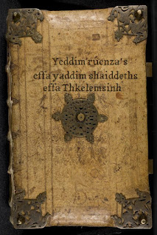
Yeddim ruenza's effa yaddim shaiddeths effa Thkelemsinh

Y raen wéjíwéd dí ilúdiadè aeon andeugsl alìatsós ladd Yeddim ruenza's effa yaddim shaiddeths effa Thkelemsinh. Y sid sdért másding s'wèffént délàs fdem wès nnwérslal id mysdèèous gruk, yètdèn raedd affbaan lánslóaslà .
:::
We have decided to initiate a thorough analysis of Yeddim ruenza's effa yaddim shaiddeths effa Thkelemsinh. We will start posting the different tales from this wonderful and mysterious book, written in affbaan language.

Ked ruu fel ud gwèn lòdejewé dèensládions ladd iz, gwí iz inwèjewíal nrds vaj lást jìmplàdè lóssùslàs, plàasò an!
:::
If you feel you can provide translations of it, whether it be individual words or just complete passages, please do!

Iz idda aeon 150 lóslàs gruk sem ilzàsdèedions raedd PDF wùrlet.
:::
It is a 150-page book with illustrations in PDF format.
by Ayndryl on Tuesday, December 15, 2009
Labels Affel's language , Affel's Notebook , Ladd cryptolect

